Chapter – I
Rational Numbers
Closure Properties of Rational Numbers
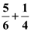
Consider the two rational numbers as and .
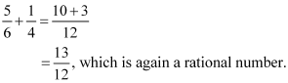
What would we get if we add these two rational numbers, i.e. what is the value of?

This means that the sum of two rational numbers and is a rational number. In other words, we can say that rational numbers are closed under addition.
Is this true for all rational numbers?
Yes. We can try for different rational numbers and see that this property is true for all rational numbers. Thus, we can say that the sum of two rational numbers is again a rational number. In other words, we can say that rational numbers are closed under addition. This property of rational numbers is known as the closure property for rational numbers and it can be stated as follows.
“If a and b are any two rational numbers and a + b = c, then c will always be a rational number”.
Are rational numbers closed under subtraction also?
Let us find out.
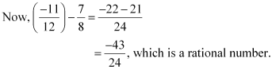
Consider two rational numbers and

Thus, rational numbers are closed under subtraction also.
Closure property of rational numbers under subtraction can be stated as follows.
“If a and b are any two rational numbers and a − b = c, then c will always be a rational number”.
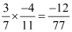
Now, let us check whether rational numbers are closed under multiplication also. For this, consider two rational numbers and.
Now, , which is a rational number.
Thus, rational numbers are closed under multiplication also.
Closure property of rational numbers under multiplication can be defined as follows.
“If a and b are any two rational numbers, then a × b = c, then c will always be a rational number”.
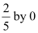
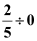
But rational numbers are not closed under division. If we consider the division of , then we will not obtain a rational number.
is not a rational number because division of a rational number by zero is not defined.
Thus, we can say that rational numbers are not closed under division.
We can summarize the above discussed facts as follows.
- Rational numbers are closed under addition, subtraction and multiplication.
- Rational numbers are not closed under division.

Commutative And Associative Properties Of Rational Numbers
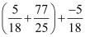
Consider the expression .
What will be the value of this expression?
If we try to find the value of this expression by usually adding the terms in the bracket first and then by adding the result so obtained to the third term, then it will take a long time. Therefore here, we can make use of commutative and associative properties of addition of rational numbers to make our calculation simpler.
Let us first study these properties for rational numbers and then we will find the value of the above expression.
The commutative property of rational numbers over addition can be stated as follows.
“If a and b are any two rational numbers, then a + b = b + a”.
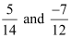
For example, consider the rational numbers
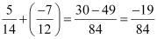
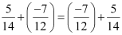
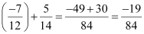
∴
Here, the numbers are arbitrary, therefore we can say that rational numbers are commutative under addition.

The associative property of rational numbers over addition can be stated as follows.
“If a, b, and c are any three rational numbers, then a + (b + c) = (a + b) + c”.
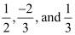
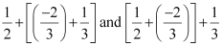
For example: consider the rational numbers
Let us first find the value of the expressions.
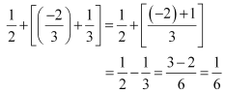
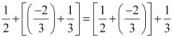
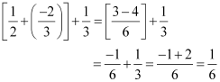
∴ We have
Here, the numbers are arbitrary, therefore we can say that rational numbers are associative under addition.
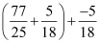
Now, let us go back to our previous problem with which we started our discussion.
We can write = (using commutative property)

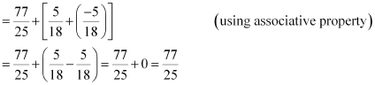

Thus, in this way, we can make use of commutative and associative properties of rational numbers to make our calculations easier and simpler.
Let us know about commutative and associative properties of rational numbers for other operations such as multiplication, division etc.
Rational numbers are commutative and associative under multiplication also.
We can write these properties for multiplication as follows.
If a, b and c are any three rational numbers, then
(i) a × b = b × a (commutative property)
(ii) a × (b × c) = (a × b) × c (associative property)
Rational numbers are not commutative and associative under subtraction.
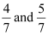
For this, let us see the following example.
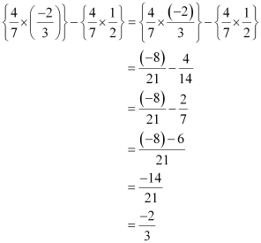
Consider the rational numbers .

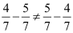
Therefore, we see that
Thus, rational numbers are not commutative under subtraction.
In the same way, we can check that rational numbers are not associative under subtraction.
Now, let us check whether rational numbers are commutative and associative under division.
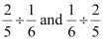
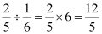
Let us find the value of .
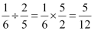
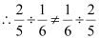

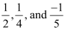
Thus, we find that rational numbers are not commutative under division.
To check associative property, let us consider three rational numbers .
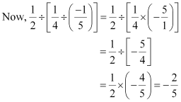
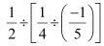
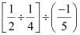
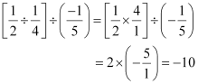
∴ ≠
Thus, we can say that rational numbers are not associative under division.
We can summarize the above facts as follows.
- Rational numbers are commutative under addition and multiplication.
- Rational numbers are not commutative under subtraction and division.
- Rational numbers are associative under addition and multiplication.
- Rational numbers are not associative under subtraction and division.
Let us now look at some more examples.
Example 1:
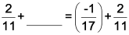
Fill in the blanks using commutative and associative properties of rational numbers.

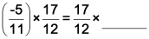

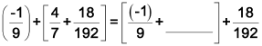
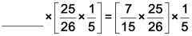

Solution:
- Rational numbers are commutative under addition.
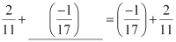
- Rational numbers are commutative under multiplication.
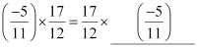
- Rational numbers are associative under addition.
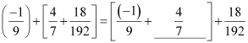
- Rational numbers are associative under multiplication.
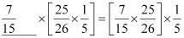
Example 2:
Find the value of the following expressions using properties of rational numbers.
- 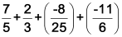
- 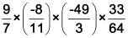

Solution:
- 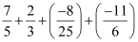
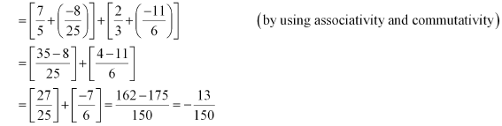
- 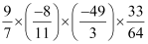
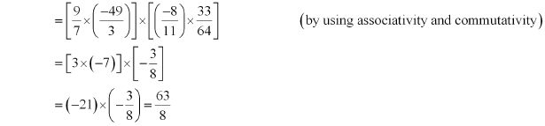
Distributive Property for Rational Numbers
Consider the rational numbers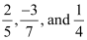.
What will be the values of the expressions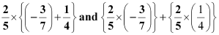?
Let us see.
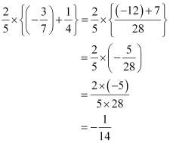
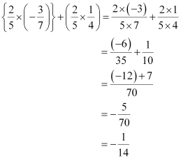
Thus, 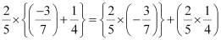
Here we see that the values of both the expressions are same. This is the distributive property of rational numbers for multiplication over addition. This property is true for all rational numbers and mathematically it can be written as follows.
If x, y and z are any three rational numbers, then x ×(y + z) = (x ×y) + (x ×z).
Does this distributive property hold for multiplication over subtraction also?
Let us check it.
Consider the rational numbers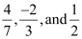.
Let us find the value of the expressions 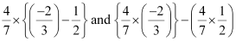
Thus, 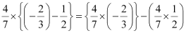
Hence, we notice that the result is same from both the ways. Thus, the distributive property of rational numbers for multiplication over subtraction can be written as follows.
“If x, y, and z are any three rational numbers, then x× (y – z) = (x×y) – (x×z)”.
Let us now look at some more examples.

Example 1:
Find the value of the following expression using appropriate properties.
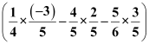
Solution:
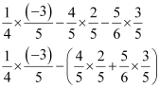
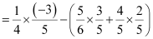[By commutative property for addition]
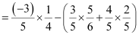[By commutative property for multiplication]
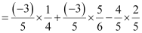
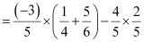[By distributive property of multiplication over addition]
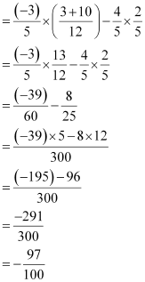
Example 2:
Solve the following expression.
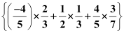
Solution:
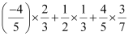
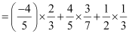[By commutative property for addition]
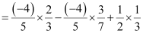
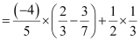[By distributive property of multiplication over subtraction]
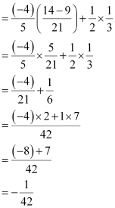
Additive and Multiplicative Inverse of Rational Numbers
As integers have additive and multiplicative inverse, similarly, rational numbers also have additive and multiplicative inverse. Go through the following video to understand this concept.
Thus, we define additive inverse and multiplicative inverse as:
“If the sum of two rational numbers is 0, then the two rational numbers are said to be additive inverse or negative of each other”.

“If the multiplication of two numbers gives the result as 1, then the two numbers are called reciprocal or multiplicative inverse of each other”.
Let us look at some more examples now.
Example 1:
Find the multiplicative inverse of the following rational numbers.
(i) (ii) (iii) (iv) (v) 0.5
Solution:
(i) The multiplicative inverse of is.
(ii) The multiplicative inverse of 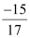is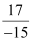.
(iii) The multiplicative inverse of is.
(iv) 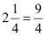
Thus, the multiplicative inverse of is.
(v) 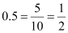
Thus, the multiplicative inverse of 0.5 is 2.
Example 2:
Write the additive inverse of the following rational numbers.
(i) (ii) 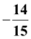 (iii) 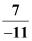 (iv)
Solution:
(i) The additive inverse of is.
(ii) The additive inverse of 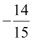is .
(iii) 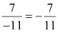
Thus, the additive inverse of is.
(iv) 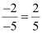
Thus, the additive inverse of is.
Let us now look at an example based on this concept.
Example:
Fill in the blanks.
- 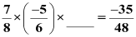
- 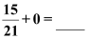
- 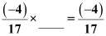
Solution:
- 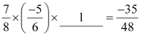(By property of multiplicative identity)
- 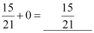(By property of additive identity)
- 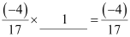(By property of multiplicative identity)

Exercise 1.1
Question 1: Using appropriate properties find:
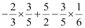
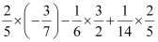
(i) (ii)

(i)
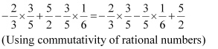
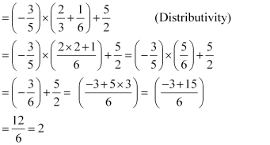

(ii)
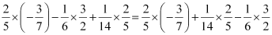(By commutativity)
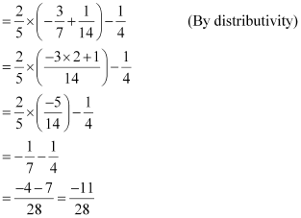

Question 2: Write the additive inverse of each of the following:
(i) (ii) (iii) (iv) (v)

(i)
Additive inverse =
(ii)
Additive inverse =
(iii) 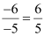
Additive inverse =
(iv) 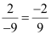
Additive inverse
(v) 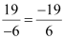
Additive inverse 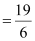
Question 3: Verify that −(−x) = x for.
(i) 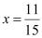 (ii) 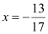

(i)
The additive inverse of is 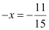as 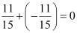
This equality represents that the additive inverse of 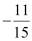is or it can be said that 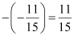i.e., −(−x) = x
(ii)
The additive inverse of is 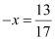as 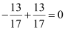
This equality represents that the additive inverse of is − i.e., −(−x) = x

Question 4: Find the multiplicative inverse of the following.
(i) (ii) 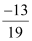(iii)
(iv) 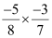(v) 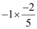(vi) −1

(i) −13
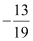
Multiplicative inverse = −
(ii)
Multiplicative inverse = 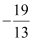
(iii)
Multiplicative inverse = 5
(iv) 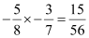
Multiplicative inverse 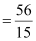
(v) 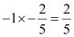
Multiplicative inverse
(vi) −1
Multiplicative inverse = −1

Question 5: Name the property under multiplication used in each of the following:
(i) 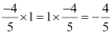
(ii) 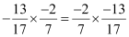
(iii) 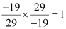
(i) 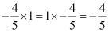
1 is the multiplicative identity.
(ii) Commutativity
(iii) Multiplicative inverse
Question 6: Multiply by the reciprocal of.
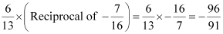
Question 7: Tell what property allows you to compute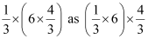.

Associativity
Question 8: Is the multiplicative inverse of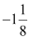? Why or why not?

If it is the multiplicative inverse, then the product should be 1.

However, here, the product is not 1 as
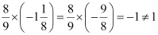

Question 9: Is 0.3 the multiplicative inverse of? Why or why not?

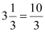
0.3 × = 0.3 × 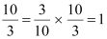
Here, the product is 1. Hence, 0.3 is the multiplicative inverse of.

Question 10: Write:

(i) The rational number that does not have a reciprocal.
(ii) The rational numbers that are equal to their reciprocals.
(iii) The rational number that is equal to its negative.
Answers:
(i) 0 is a rational number but its reciprocal is not defined.
(ii) 1 and −1 are the rational numbers that are equal to their reciprocals.
(iii) 0 is the rational number that is equal to its negative.

Question 11: Fill in the blanks.

Answers:
(i) No
(ii) 1, −1
(iii)
(iv) x
(v) Rational number
(vi) Positive rational number

Exercise 1.2
Question 1: Represent these numbers on the number line.
(i) (ii)
(i) can be represented on the number line as follows.
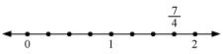
(ii) can be represented on the number line as follows.
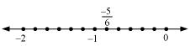
Question 2: Represent 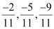on the number line.
can be represented on the number line as follows.
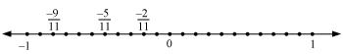
Question 3: Write five rational numbers which are smaller than 2.
2 can be represented as.
Therefore, five rational numbers smaller than 2 are
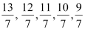
Question 4: Find ten rational numbers between and.
and can be represented as 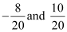respectively.
Therefore, ten rational numbers between andare
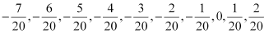
Question 5: Find five rational numbers between
(i) 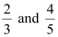
(ii) 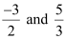
(iii) 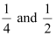
(i) can be represented as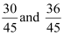 respectively.
Therefore, five rational numbers between are
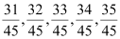
(ii) 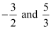can be represented as 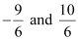respectively.
Therefore, five rational numbers between are
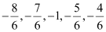
(iii) can be represented as 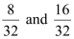respectively.
Therefore, five rational numbers between are
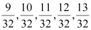
Question 6: Write five rational numbers greater than − 2.
−2 can be represented as −.
Therefore, five rational numbers greater than −2 are
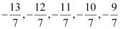
Question 7: Find ten rational numbers between and.
and can be represented as 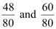respectively.
Therefore, ten rational numbers between and are
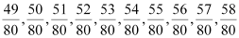

- Rational numbers arc closed under the operations of addition, subtraction and multiplication
- 2. The operations addition and multiplications are
- Commutative for rational numbers.
- Associative for rational numbers.
- The rational number 0 is the additive identity for rational numbers.
- The rational number 1 is the multiplicative identity for rational numbers.
- The additive inverse of the rational number $\frac{a}{b}$ is —$\frac{a}{b}$ and vice-versa.
- The reciprocal or multiplicative inverse of the rational number $\frac{a}{b}$ is $\frac{c}{b}$ if $\frac{a}{b}$ x$\frac{c}{b}$ = 1.
- Distributivity of rational numbers: For all rational numbers a, b and c,
a(b + c)—ab + an and a(b — c)=ab — c
- Rational numbers can be represented on a number line.
- Between any two given rational number there are countless rational numbers. The idea of mean helps to find rational numbers between two rational numbers.

